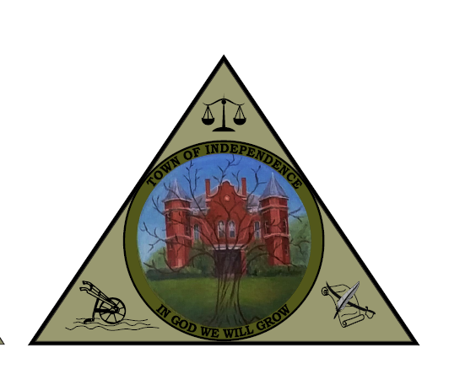
TOWN OF INDEPENDENCE
REGULAR SCHEDULED COUNCIL MEETING
TUESDAY DECEMBRER 10, 2024
INDEPENDENCE, VIRGINIA
5:00 PM
329 DAVIS STREET
INDEPENDENCE, VA 24348

COUNCIL MEMBERS PRESENT: Mayor Mark Miller, Jason Cassell, Buddy Halsey, Joan Collins and Kit Marshall.

COUNCIL MEMBERS ABSENT: Vice Mayor, Jim Meier.

TOWN STAFF PRESENT: Roger Brooks, Town Attorney, Matthew Adams, Police Chief, Kim Farmer, Town Clerk, and Terry Osborne, Public Works Director.

CITIZENS & GUESTS: Aaron Davis, Sandra Venzie, Larissa Venzie, Shannon Miller, Jennifer Snow, and Michelle Pridgen.

COUNCILMAN JASON CASSELL made a motion for Council to go into closed session citing VAFOIA Section 2.2-3711, to discuss personnel and contract negotiation asking the Town Attorney Roger Brooks, and Aaron Davis to stay. COUNCILMAN BUDDY HALSEY seconded; motion carried with all ayes.

COUNCILMAN JASON CASSELL made a motion for Council to go into open session citing VAFOIA Section 2.2-3712 that only matters in closed session were convened for and permitted under was discussed. Mayor Miller asked for a roll call vote:

Jason Cassell – I So Certify Buddy Halsey-I So Certify
Kit Marshall- I So Certify Joan Collins – I So Certify

- Public Hearing-None
- Call to Order
  - Welcome/Decorum- Mayor Mark Miller called the meeting to order this 10th day of December 2024 and declared a quorum present.
  - Approval of Agenda, Consent Agenda, Meeting Minutes-Mayor Mark Miller asked for a motion. COUNCILWOMAN KIT MARSHALL made a motion to approve the agenda, and prior months minutes, as presented. COUNCILWOMAN JOAN COLLINS seconded; motion carried with all ayes.
- Reports, Presentations or Requests
- Old Business
  - Employee luncheon is on December 11th, 12pm at the IVFD
  - Public hearing for comments on dissolving the EDA board is scheduled for January 14, 2025, 6pm at the IVFD
  - Update on new VCWA Representative-Councilman Jason Cassell
    - COUNCILMAN JASON CASSELL made a motion to appoint Kenneth Vaught to serve on the VCWA board effective 12-18-2024 to replace Laura Ratcliffe. COUNCILWOMAN JOAN COLLINS seconded; motion carried with all ayes.
- New Business
  - Oak Hall snow removal agreement. This change specifies what needs to be cleared along with a cost of $300 per removal. COUNCILMAN BUDDY HALSEY made a motion to authorize the contract change regarding snow removal. COUNCILMAN JOAN COLLINS seconded; motion carried with all ayes.
- Town Staff Report
  - Town Clerk/Treasurer: (Kim Farmer)
    - Town Clerk, Kim Farmer, gave council the financial report. G&A revenue was $85,448, which includes $16,589 from the litter grant which will be disbursed to Grayson County, Town of Fries and Town of Independence, water revenue $75,452 and sewer revenue $88,307. Expenses were above average for the month due to VRSA quarterly payment of $9,090, engineering $157,515, bond counsel $8,500, and election cost of $551. VOF grant monies spent for the month were $2,900 for the sign at Town Park.
  - Police Report: (Chief Matthew Adams)
    - Chief Adams stated that the Christmas parade held at night was a success. Randy Ferrell, training director at the Police Academy, retired. Dennis Lambert will be replacing him effective February 1st. Policeman Kevin Watson was involved in a dangerous situation which led to a felony arrest in Town.
  - Public Works Director- (Terry Osborne)
    - Public Works Director Terry Osborne stated that his written report was in packets. The Lane Group is gathering details on Reeves bridge to give the Town an estimate to replace it. Construction for the sewer I&I project is scheduled to begin March 1, 2025. The air leak at the wastewater treatment plant is getting worse. The quote received from Boggs which was the lowest, was $154,000. A blower went out at the wastewater treatment plant. The cost to rebuild it is $4,165 a new one is $12,000. Public Works Director Terry Osborne asked council to consider options for the Darco pump station. Town employees currently have to empty the sewage waste basket by hand every week. The Town received an estimate of $130,000 to redo the whole pump station. Public Works Director Osborne recommended putting in a septic tank. Councilman Jason Cassell asked if the Town could do the work. Public Works Director Osborne stated that he would rather have a company licensed to do the work. The estimated cost would be $3k to $4k. Public Works Director Osborne stated that he has full-size prints for the Lakeview and Grayson Street project if anyone would like to review.
- Town Manager’s Report-
- Mayor’s Report:
  - Mayor Mark Miller stated that the Town received several applicants for the Town Manager position. Interviews will be setup within the next few days.
  - FEMA and VDEM personnel came and had a progress meeting which went very well.
  - Christmas Parade was a great hit. Mayor Miller thanked the public works department for all their help.
- Town Attorney’s Report:
  - Town Attorney Roger Brooks no matters for open session.
- Committee Updates
  - Personnel Committee – Councilman Cassell Nothing to report.
  - Finance Committee – Vice Mayor Meier Nothing to report.
  - Community Development-Councilwoman Marshall thanked Mayor Miller and Shannon Miller for help putting up the lights in the Town Park. The holiday decorations are in place that we have. Councilwoman asked about moving the Christmas Parade time up 30 minutes due to it being to dark to see.
- Community Matters – Registered Speakers and Public Comment-
  - Michelle Pridgen, Independence Farmer’s Market, stated that they had a extra Thanksgiving Market however, the weather was not cooperative. It was very cold. Ms. Pridgen thanked Mayor Miller for all of his help. Ms. Pridgen stated that all in all the market had a good year. Town Park planting/working will be around May 15th. Volunteers will check perennials and other plants to see if coming up.
- Closed Session
  - Personnel
  - Litigation
  - Contract Negotiation
  - Economic Development

- Adjourn
-Meeting Decorum-
All official meetings are to be observed by the following decorum:
- Behavior during all official meetings shall be consistent with the behavior exercised in any court or legislative room found within the Commonwealth of Virginia; and,
- There shall be no outbursts, heckling or other forms of disrespectful behavior by any individuals present within these chambers; and,
- Persons wishing to speak shall do so respectfully and in accordance with the applicable Rules of Procedures and/or at the specific direction of the presiding official; and,
- Out of respect for the official business being conducted, for those conducting the official business and for those present for same purpose, there shall be no private conversations taking place in the audience or other forms of distractive behavior or nuisance; and
- Please turn off cell phones and other such devices before entering the meeting room.

