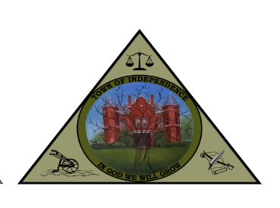
TOWN OF INDEPENDENCE
COMMITTEES
JANUARY 2025

- INFRASTRUCTURE COMMITTEE

CHAIRMAN | BUDDY HALSEY | (276)233-8522 | bhalsey@independenceva.com
MEMBER | JASON CASSELL | (276)768-8169 | jcassell@independenceva.com
MEMBER | OPEN SEAT
MEMBER | MARK MILLER | (704)622-9111 | mmiller@independenceva.com
MEMBER | TERRY OSBORNE | (276)768-0373 | tosborne@independenceva.com

- PERSONNEL COMMITTEE

CHAIRMAN | JASON CASSELL | (276)768-8169 | jcassell@independenceva.com
MEMBER | JOAN COLLINS | (276)233-5494 | jcollins@independenceva.com
MEMBER | BUDDY HALSEY | (276)233-8522 | bhalsey@independenceva.com
MEMBER | MARK MILLER | (704)622-9111 | mmiller@independenceva.com
MEMBER | TOWN MANAGER

- COMMUNITY DEVELOPMENT COMMITTEE

CHAIRMAN | KIT MARSHALL | (276)237-5430 | kmarshall@independenceva.com
MEMBER | AARON DAVIS | (276)237-2528 | adavis@independenceva.com
MEMBER | OPEN SEAT
MEMBER | MARK MILLER | (704)622-9111 | mmiller@independenceva.com
MEMBER | MATTHEW ADAMS | (276)768-7566 | matthew@independenceva.com

- BUDGET/FINANCE COMMITTEE

CHAIRMAN | JOAN COLLINS | (276)233-5494 | jcollins@independenceva.com
MEMBER | AARON DAVIS | (276)237-2528 | adavis@independenceva.com
MEMBER | KIT MARSHALL | (276)237-5430 | kmarshall@independenceva.com
MEMBER | MARK MILLER | (704)622-9111 | mmiller@independenceva.com
MEMBER | TOWN MANAGER
MEMBER | KIM FARMER | (276)768-8734 | kim@independenceva.com

