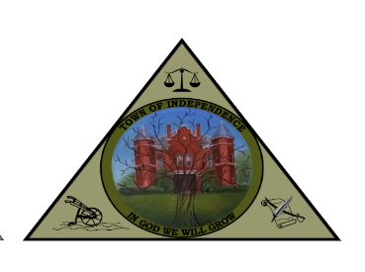
TOWN OF INDEPENDENCE
COMMITTEES
JANUARY 2026

- INFRASTRUCTURE COMMITTEE

CHAIRMAN | BUDDY HALSEY | (276)233-8522 | bhalsey@independenceva.com
MEMBER | JASON CASSELL | (276)768-8169 | jcassell@independenceva.com
MEMBER | AARON DAVIS | (276)237-2528 | adavis@independenceva.com
MEMBER | MARK MILLER | (704)622-9111 | mmiller@independenceva.com
MEMBER | JOAN COLLINS | (276)233-5494 | jcollins@independenceva.com

- PERSONNEL COMMITTEE

CHAIRMAN | AARON DAVIS | (276)237-2528 | adavis@independenceva.com
MEMBER | JOAN COLLINS | (276)233-5494 | jcollins@independenceva.com
MEMBER | BUDDY HALSEY | (276)233-8522 | bhalsey@independenceva.com
MEMBER | MARK MILLER | (704)622-9111 | mmiller@independenceva.com
MEMBER | JASON CASSELL | (276)768-8169 | jcassell@independenceva.com

- COMMUNITY DEVELOPMENT COMMITTEE

CHAIRMAN | MARK MILLER | (704)622-9111 | mmiller@independenceva.com
MEMBER | AARON DAVIS | (276)237-2528 | adavis@independenceva.com
MEMBER | BUDDY HALSEY | (276)233-8522 | bhalsey@independenceva.com
MEMBER | JOAN COLLINS | (276)233-5494 | jcollins@independenceva.com
MEMBER | JASON CASSELL | (276)768-8169 | jcassell@independenceva.com

- BUDGET/FINANCE COMMITTEE

CHAIRMAN | JOAN COLLINS | (276)233-5494 | jcollins@independenceva.com
MEMBER | AARON DAVIS | (276)237-2528 | adavis@independenceva.com
MEMBER | BUDDY HALSEY | (276)233-8522 | bhalsey@independenceva.com
MEMBER | MARK MILLER | (704)622-9111 | mmiller@independenceva.com
MEMBER | JASON CASSELL | (276)768-8169 | jcassell@independenceva.com

